Postgraduate Students using a Windows 7 University - managed device
With the move to OneDrive for Business, your Home Drive (P:\ Drive) will no longer be available in the usual way. Your files will be accessible via OneDrive for Business; however, if you are using a Windows 7 desktop you will have to configure the synchronising yourself manually.
From the Start Menu,
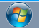
Select Microsoft OneDrive
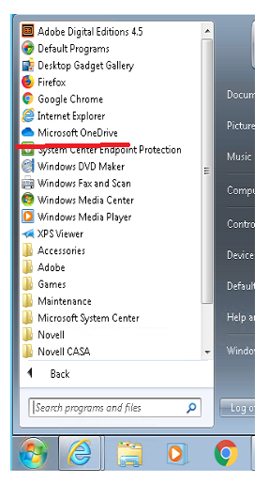
Enter your Swansea University email address to configure the tool.
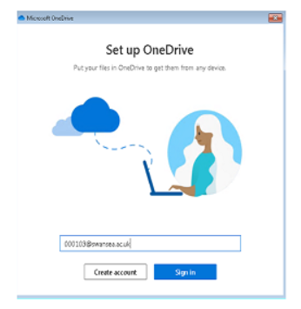
Follow the Wizard instructions to complete the set up
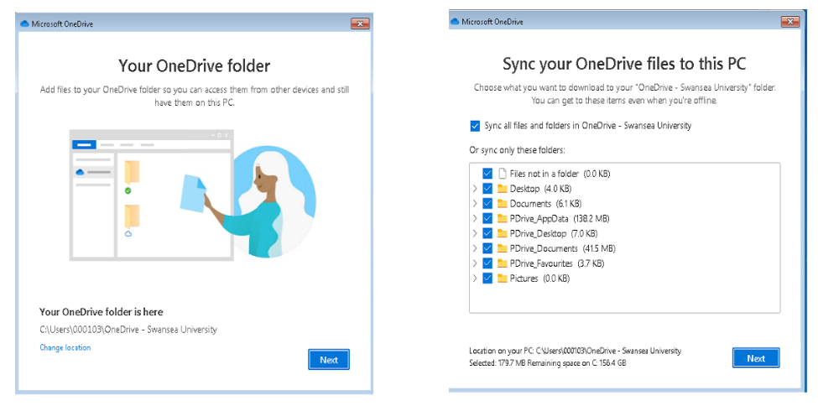
Once this is complete, you can browse your files in File Explorer
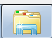
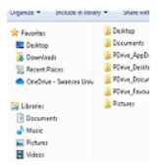

If you cannot see Microsoft OneDrive in the Start menu, please try the following:
In the Zenworks Unified Desktop window, under Microsoft Office, right click the OneDrive application and Open it. If after doing this, OneDrive still does not appear in the Start Menu, right click on the icon in Zenworks and click Verify.
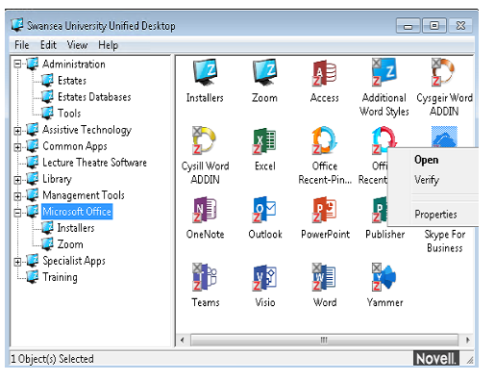

If you see OneDrive synchronisation errors (see image below), please try the following:
If OneDrive does not synchronise (Sync), open an Internet Browser and go to portal.office.com. Sign in using your University email address and select the OneDrive app from the menu. When OneDrive opens in your browser, you will see an option to “Sync”. Select Sync.
